The second alternative strategy idea was to take advantage from the capability of a tangent maneuver to change all the orbital parameters (inclination ones excluded): therefore, the entire structure of this strategy has been projected to condense in a single maneuver the change of argument of perigee and the distancing from the main attractor (which is necessary to contain the cost of the subsequent orbital inclination change). The outcome of these first two maneuvers will be an orbit in the same plane of the final orbit and, as previously planned, with the same perigee argument that the final orbit has. In order to fix the semi-major axis and the eccentricity (the only parameters that differ between the current and the final orbit), a bitangent transfer will be performed from the apogee of the first orbit to the perigee of the second orbit.

The main difficulty in the design of this strategy is to obtain the desired change of perigee argument during the tangent maneuver. It is easier to find the perigee argument value needed in the plane of the initial orbit by proceeding backwards. By knowing the inclination and the RAAN of the two orbital planes and the perigee argument of the final orbit, it is possible to obtain information about the initial perigee argument and about the two maneuvering angles:

Case with :

Since the transverse orbital speed is lower at (which is in the quadrant III), it has been selected to be the point where the orbital inclination change maneuver will be performed. After obtaining the information on the perigee argument that should be reached in the initial orbital plane, it is necessary to design the tangent maneuver to achieve this value. Since the problem is under determined - and therefore infinite maneuvers exist – it is chosen to parametrize the tangent burn ; a function has been defined in MATLAB to numerically solve the following system (simplified in an analytic way solving for ):

The result is a single nonlinear equation that can be studied and solved by using a numerical method similar to the one used on the eccentricity graph of the previous strategy: it always has two solutions, but only one can be considered acceptable (since the other one returns a negative eccentricity) or none (for too high values of the parameter ).

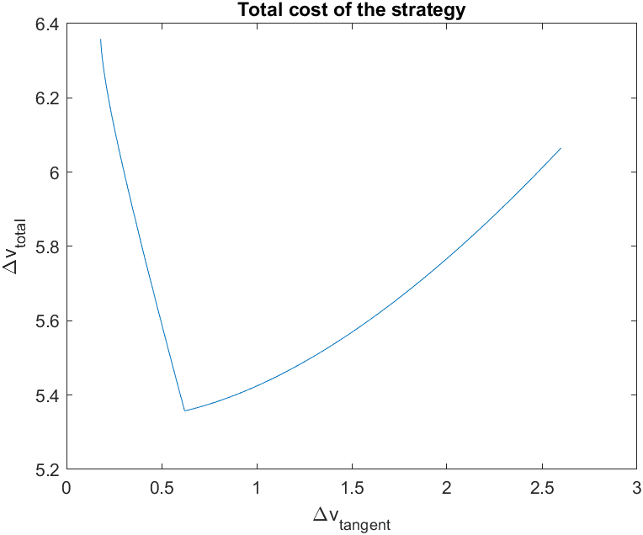By choosing an acceptable initial burn value, the strategy is completely defined, and it is concluded after the change of orbital plane by a simple bitangent maneuver from apogee to perigee: therefore, the software MATLAB has been used to obtain the plot of the total cost of the strategy as a function of the tangent burn, and it is chosen the value by which such cost is minimized.

From the data reported in the tables it is also possible to observe that the second burn of the last maneuver is really small, because the two orbits are almost perfectly identical with a single-pulse maneuver in the apocentre: therefore, it can be deduced (the demonstration is not subject of this short relation) that the optimal strategy would be to fix the point of intersection between the plane-change orbit and the final one in their apogees, so as to adjust the semi-major axis and the eccentricity with a single burn. This constraint would make the strategy unique and fully defined by its equations.